МИНИСТЕРСТВО НАУКИ И ВЫСШЕГО ОБРАЗОВАНИЯ  
РОССИЙСКОЙ ФЕДЕРАЦИИ

федеральное государственное автономное   
образовательное учреждение высшего образования  
«Самарский национальный исследовательский университет   
имени академика С.П. Королева»

(Самарский университет)

Институт информатики и кибернетики

Кафедра геоинформатики и информационной безопасности

**Отчет по лабораторной работе №1**

Дисциплина: «Развертывание и жизненный цикл программного обеспечения»

Тема: **«VM and RAID. MINIKUBE»**

Выполнил: Моисеев И.А..

Группа: 6412-100503D

Самара 2023

**TASK**

Steps:

1. Create virtual machine with debian/ubuntu/centos or download preinstalled image (<https://www.osboxes.org/>). It should be withoug GUI.
2. Set hostname = your surname.
3. Add simple raid1 to virtual machine: *nix os system on 1-st hdd, 2d and 3d hdds are in raid1. 1 (with star). Only two hdds. Os system on raid1, based on this two hdd.
4. How to test raid1. Create file on raid1 file system. Turn off vm and remove one of the hhds from vm. Turn on vm. File should be accessible.
5. Add new hdd and sync it to raid1.
6. Install and run local Kubernetes cluster with **minikube**

* Use steps from Kubernetes install Tools <https://kubernetes.io/docs/tasks/tools/> Make report with screens of:
* minicube version command output
* opened Dashboard in your web-browser
* web-abblication in your web-browser (<http://localhost:7080/> in tutorial)

1. Deploy hello-minikube app
2. Create Assignment1 report and send it by e-mail (docx/link to google doc) or through creation repo fork + pull request.

**PROCEDURE**

Install an Ubuntu Server 22.04 virtual machine using VMWareand add two additional HDDs to the VM:

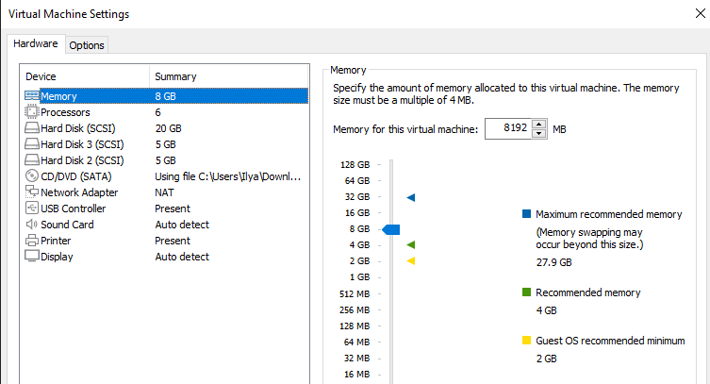

List all the disks of the VM using the lsblk command: 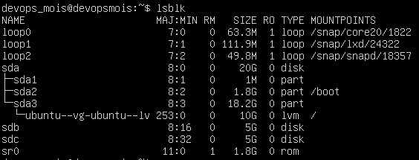

Create RAID1 based on sdb and sdc. In order to do that, create two primary partitions sdb1 and sdc1 respectively with the fdisk utility program:

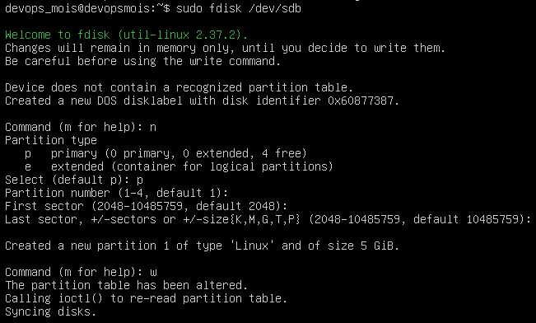

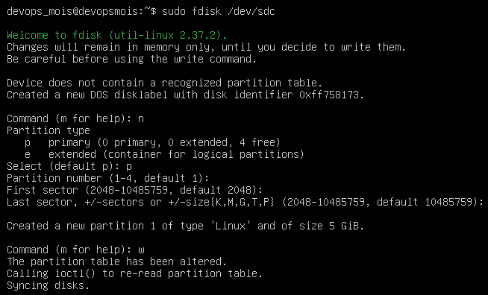

Check for creation success:

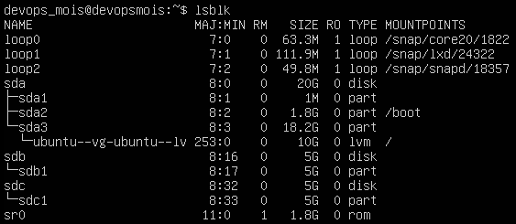

The two partitions created successfully.

Create a RAID1 array in /dev/md0 based on the created partitions using the mdadm command:

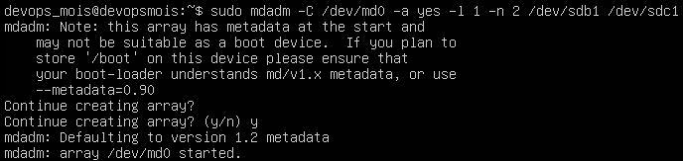

Create a file system based on RAID1:

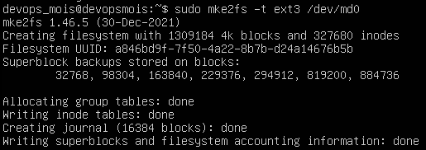

Mount the file system:



Check for success:

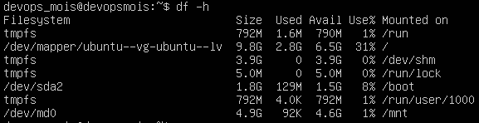

Save the created partitions to mount them automatically each time the system boots. In order to do that, get the UUID of the RAID1 array:



Then edit the /etc/fstab file containing the boot information and paste the UUID in there with corresponding options:



Display the edited file:

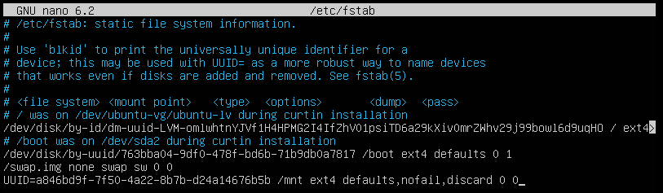

Test RAID1. In order to do that, add a test file in the /mnt directory as shown on the picture below:



Then remove sdc1 from RAID1 and check if the file is left: 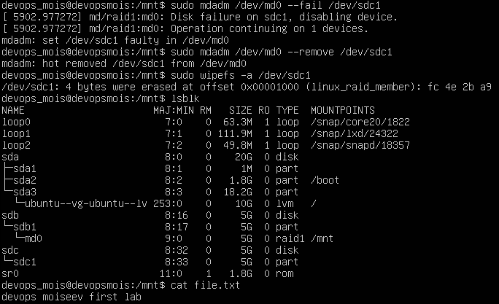

The file left unaffected.

Turn off the VM and remove one of the disks:

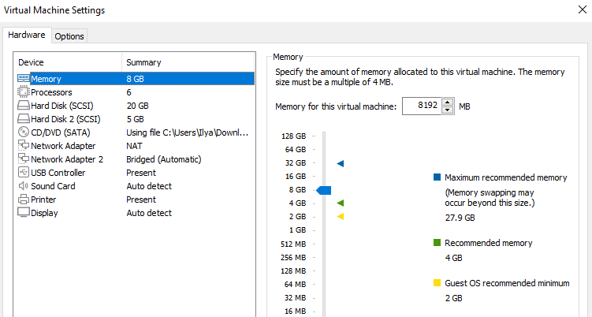

Turn the VM back on and display its disks to check if sdc completely removed but the file still left unaffected:

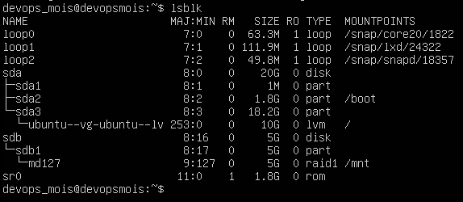

Turn the VM off and add a new HDD to it:

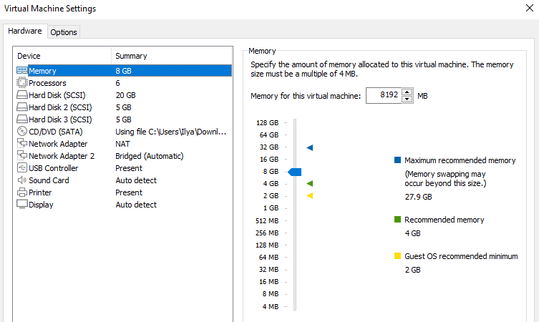

Turn the VM back on and display its disks:

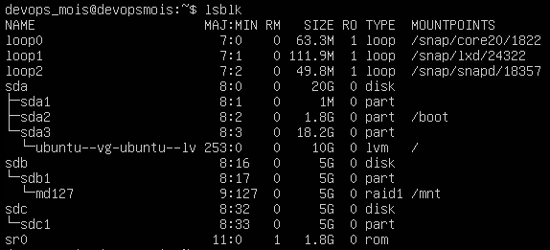

The new HDD detected but not added to RAID. Add it with the following command and check for success:

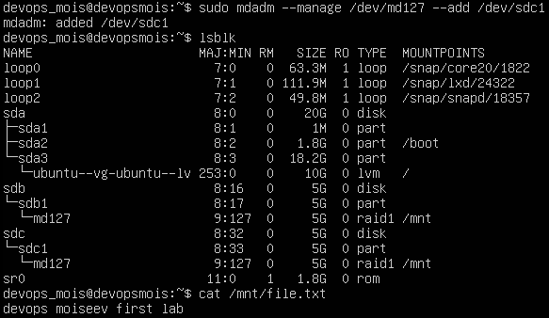

The test file still left unaffected.

Check start docker

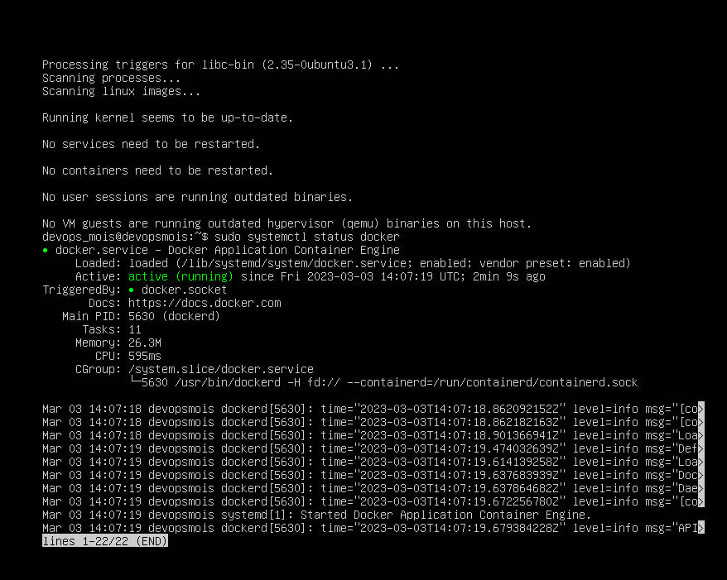

Check install minikube

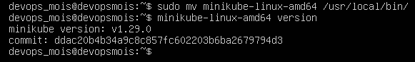

Start minikube

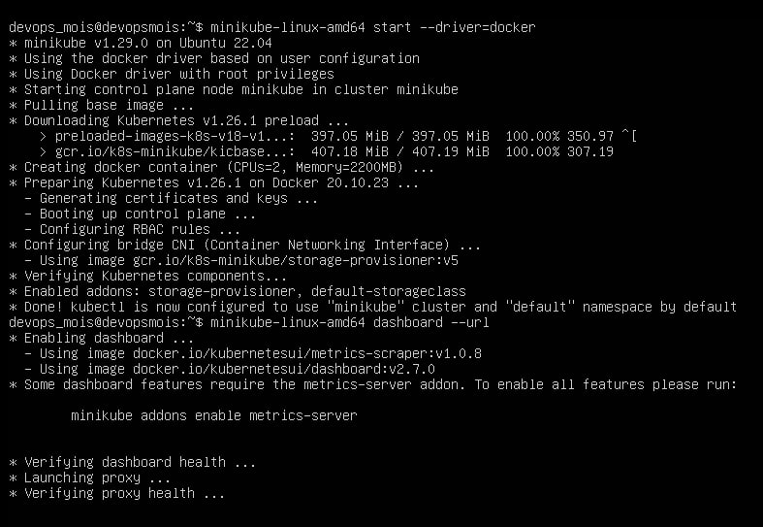

Add proxy



Change port



Get token 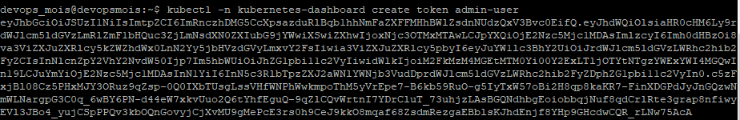

Open Dashboard

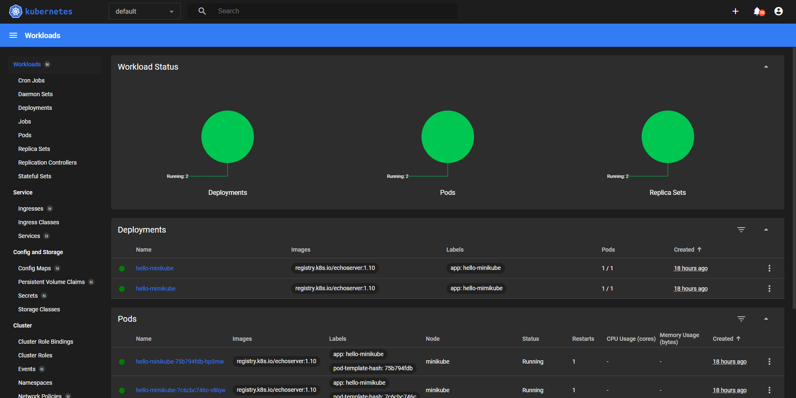

Deploy with command

*kubectl create deployment hello-minikube-2 --image=docker.io/nginx:1.23   
kubectl expose deployment hello-minikube-2 --type=NodePort --port=80   
kubectl get services hello-minikube-2  
kubectl port-forward service/hello-minikube-2 7080:80 –address 0.0.0.0*

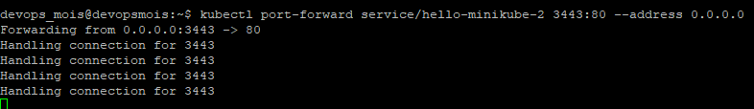

Deploy

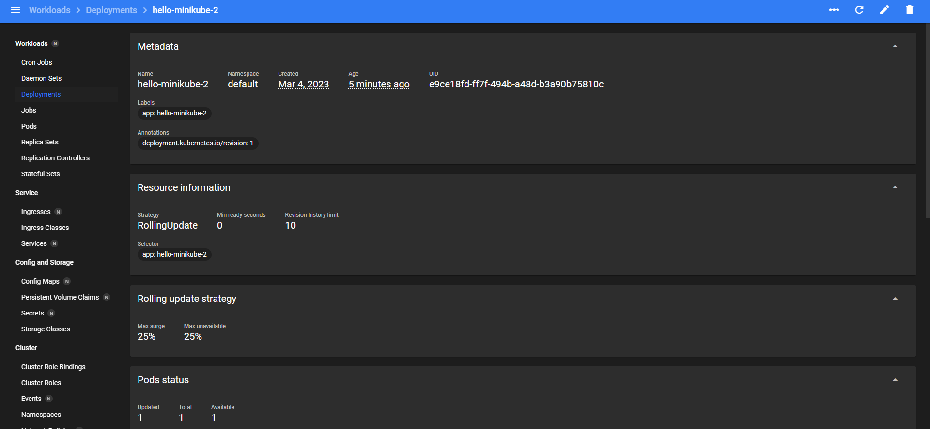

**CONCLUSION**

In the conclusion of the laboratory work, the basic utilities of the Ubuntu system studied for working with the file system, partitioning and creating RAID arrays; run minikube and deploy app; all steps completed successfully.